COPE

An Online Self-Care Group for Counselors in Training

COPE is a 10-week online program consisting of psychoeducation, interactive and experiential activities that let you practice self-care.
The group will meet online on through video chat, email, and social media. All activities are self-paced and the group will web conference together 5-6 times.
The Group is Open to Masters and Doctoral Students
Benefits of COPE:
- Develop skills to cope with stress of graduate school
- Build peer social support
- Improve work-life balance
- Learn skills that you can use with your clients
Topics Include: Mindfulness, Self-Compassion, Body Flow, Enriching Interpersonal Relationships, Time Management and Organization and much more!
Group Begins the week of September 11th 2017
To Register Use this link https://bsu.qualtrics.com/jfe/form/SV_8omNDsHFnSBKVlX
or Scan the QR Code

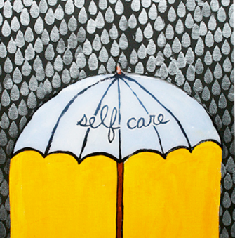
Questions? email Yamini (ynbellare@bsu.edu) or Corie (clloisellehe@bsu.edu)

